  - FUNDAMENTALS OF DATA SCIENCE

  - Experiment 1

Exp No:1.a
Analyze the trend of data science job postings over the last decade

Description: Use web scraping (e.g., BeautifulSoup) or APIs (e.g., LinkedIn API) to gather data on the number of data science job postings each year. Use pandas for data manipulation and matplotlib/seaborn for visualization.
Code:
Import pandas as pd
import matplotlib.pyplot as plt
data = {'Year': list(range(2010, 2021)), 'Job Postings': [150, 300, 450, 600, 800, 1200, 1600, 2100, 2700, 3400, 4200]}
df = pd.DataFrame(data)
plt.plot(df['Year'], df['Job Postings'], marker='o')
plt.title('Trend of Data Science Job Postings')
plt.xlabel('Year')
plt.ylabel('Number of Job Postings')
plt.show()

Sample Data Input:
Year = 2010, 2011, 2012, 2013, 2014, 2015, 2016, 2017, 2018, 2019, 2020 Job
Postings = 95, 140, 225, 340, 510, 720, 980, 1320, 1810, 2450, 3250
Sample Output:

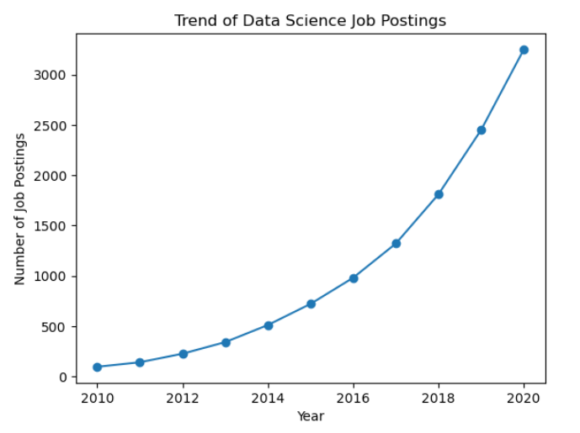

Exp No:1.b
Analyze and visualize the distribution of various data science roles (Data Analyst, Data Engineer, Data Scientist, etc.) from a dataset.
Description: Use a dataset of job postings and categorize them into different roles. Visualize the distribution using pie charts or bar plots.
CODE:
import matplotlib.pyplot as plt
roles = ['Security Analyst', 'Penetration Tester', 'Security Architect', 'Incident Responder', 'Compliance Officer']
counts = [420, 180, 150, 210, 90]
plt.bar(roles, counts)
plt.title('Distribution of Data Science Roles')
plt.xlabel('Role')
plt.ylabel('Count')
plt.show()

Sample Data Input:
roles = Data Analyst, Data Engineer, Data Scientist, ML Engineer, Business Analyst.
counts = 300, 500, 450, 200, 150.

Sample Output:
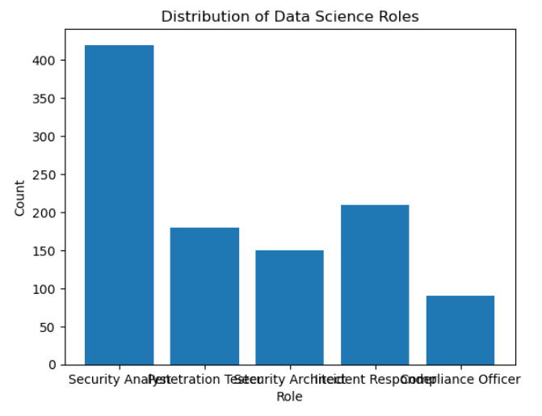

  - Exp No:1.c
Conduct an experiment to differentiate Structured , Un-structured and Semi structured data based on data sets given.

Description:
Create small datasets for each type and explain their characteristics.

CODE:

# Structured data example
structured_data = pd.DataFrame({ 'ID': [1, 2, 3], 'Name': ['Alice', 'Bob', 'Charlie'], 'Age': [25, 30, 35] })
print("Structured Data:\n", structured_data)
# Unstructured data example
unstructured_data = "This is an example of unstructured data. It can be a piece of text, an image, or a video file."
print("\nUnstructured Data:\n", unstructured_data)
# Semi-structured data example (JSON)
semi_structured_data = {'ID': 1, 'Name': 'Alice', 'Attributes': {'Height': 165, 'Weight': 68}}
print("\nSemi-structured Data:\n", semi_structured_data)

OUTPUT:
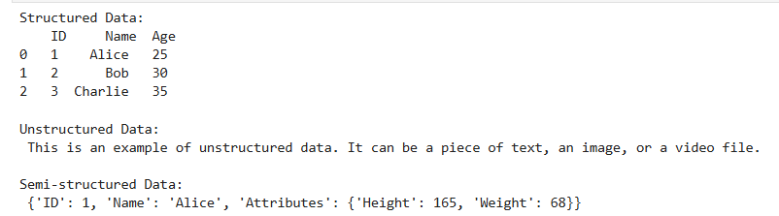

  - Exp No:1.d
Conduct an experiment to encrypt and decrypt given sensitive data.

Description:
Use the cryptography library to encrypt and decrypt a piece of data.

CODE:
# Generate key and encrypt data
from cryptography.fernet import Fernet
key = Fernet.generate_key()
f = Fernet(key)
token = f.encrypt(b"Fundamentals of Data Science")
token
b'...'
f.decrypt(token)
b'Fundamentals of Data Science'
key = Fernet.generate_key()
cipher_suite = Fernet(key)
plain_text = b"Fundamentals of Data Science."
cipher_text = cipher_suite.encrypt(plain_text)
# Decrypt data
decrypted_text = cipher_suite.decrypt(cipher_text)
print("Original Data:", plain_text)
print("Encrypted Data:", cipher_text)
print("Decrypted Data:", decrypted_text)

OUTPUT:

